**Exercise: Adventure Works executive summary**

**Introduction**

You've come a long way on your journey to master data analytics. By now, you're well-versed in visualizing and analyzing data in Power BI. Today, you'll apply that knowledge in a scenario, working on an Adventure Works Microsoft Power BI report that urgently needs your expertise. In this exercise, you'll be doing more than just creating visuals; you'll translate data into actionable insights for decision-making at the highest levels. Specifically, you will be asked to:

* Utilize the table, column chart, line chart, KPI, and Q&A visuals to bring data to life.
* Implement forecasting on your line chart to anticipate future trends.
* Employ the Q&A visual to enable a more natural conversation with data.

**Scenario**

You've just received an email marked "URGENT" from the executives at Adventure Works. They've heard about your expertise in data analytics and have a pressing request: "We need a comprehensive Power BI report and dashboard ASAP!" Now, the room you find yourself in isn't just any room; you're in the executive suite of Adventure Works, surrounded by the company's top minds. These decision-makers juggle multi-million-dollar budgets, eyeing global expansion and continually adapting to ever-changing market dynamics. They don't just want data; they need actionable insights, and they need them now.

The executives understand that in the modern business landscape, data isn't just an asset; it's the essence of strategic decision-making. As you look around, you see various department heads clutching different pieces of the data puzzle—sales printouts, customer demographics, and inventory reports—but they're fragmented, disjointed, and not speaking to each other. The executives look to you to make the data understandable and actionable. You've been given a significant responsibility: to harness the potential of sales and customer data that will influence high-stakes decision-making. So, are you ready to dive in?

**Instructions**

Download and open the Adventure Works Power BI report titled *Adventure Works executive summary.pbix* and follow the prompts below to complete the exercise.

[Adventure Works executive summary](https://d3c33hcgiwev3.cloudfront.net/-JNhBdRzSBOSAxFlLwL9_Q_7c1ca4a988d040b69905ec87900a82e1_Adventure-Works-executive-summary.pbix?Expires=1712102400&Signature=CYbNzJepaymscwaSCb6rt1sUhVULUJBS7bu0j4bABoPr2z6s2ogH4NpWypOB79S8TBKcOPaZJkOKfAAyHoASK2nVt-p6wgYu5~EU2cw~iGmAUHKfbB67QBxRREC4VZxc00h2Uzh0lKsMoWaUdMy6j18YOUCC2-F-Xr1df4EyNRM_&Key-Pair-Id=APKAJLTNE6QMUY6HBC5A" \t "_blank)

[PBIX File](https://d3c33hcgiwev3.cloudfront.net/-JNhBdRzSBOSAxFlLwL9_Q_7c1ca4a988d040b69905ec87900a82e1_Adventure-Works-executive-summary.pbix?Expires=1712102400&Signature=CYbNzJepaymscwaSCb6rt1sUhVULUJBS7bu0j4bABoPr2z6s2ogH4NpWypOB79S8TBKcOPaZJkOKfAAyHoASK2nVt-p6wgYu5~EU2cw~iGmAUHKfbB67QBxRREC4VZxc00h2Uzh0lKsMoWaUdMy6j18YOUCC2-F-Xr1df4EyNRM_&Key-Pair-Id=APKAJLTNE6QMUY6HBC5A" \t "_blank)

**Step 1: Create core visualizations**

**Table visualization**

In a bustling company like Adventure Works, getting lost in the noise of numerous SKUs, fluctuating sales, and changing order statuses is easy. First, create a table visualization that will serve as a quick reference, telling the executive team what products are selling and where it’s at in the delivery pipeline.

1. From the **Visualizations** pane, select the **Table** icon to create an empty table visualization on the canvas.
2. On the **Fields** pane, select the **Sales** table to expand it and view its fields.
3. Drag **Product ID** from the **Fields** pane to the **Columns** well in the **Visualizations** pane.
4. Next, drag **Product Name**, **Order ID**, **Order Status**, and **Order Total** to the same **Columns** well.
5. In the **Format** tab, expand the **Style** preset option and select the **Minimal** preset from the available dropdown.
6. Select and drag the edges of the table visualization on your canvas to resize it and place the visualization on the right side of the canvas.

**Column chart**

It's not enough to know what sold; it's crucial to know what's selling dominantly and what's not leaving the warehouse. A column chart instantly displays which product categories at Adventure Works are revenue-generators and which need a strategic revisit.

1. Select the **Clustered column** chart icon in the **Visualizations** pane.
2. Drag **Product Category** from the **Sales** table and drop it into the **X-Axis** well.
3. Drag **Order Total** from the same **Sales** table and drop it into the **Y-Axis** well.
4. In the **Format** tab, locate the **Columns** > **Colors** option. Input **Dark Blue: #2D386D**for a unified look.
5. Drag **Order Quantity** and **Product Weight** fields from the **Sales** table into the **Tooltips** field well.
6. Upon selecting the ellipsis at the visualization's top right corner, select the **Sort Axis** dropdown, followed by **Sum of Order Total**. Then select **Sort ascending** to sort the values in ascending order.
7. Observe the column chart results and note the **Product Category** with the lowest **Order Total** value.

**Line chart**

Remembering the conversation while seated in the executive suite, you overheard the Adventure Works executive team ponder “When did the sales peak? When did they drop?” as their seasonal strategies depend on these insights. Sales figures are meaningless without context, so you decide to take action and create a line chart.

1. Select the **Line chart** icon in the **Visualizations** pane.
2. Drag **OrderDate** from the **Sales** table into the **X-Axis** well.
3. Then, drag **Order Total** and put it in the **Y-Axis** well.
4. Select and drag the edges of the **Line chart** visualization on your canvas to resize it, and place it in the middle of the canvas, below the column chart, next to the table visualization.

**Step 2: Create KPIs**

KPIs offer the executive team a precise performance check into questions like, "Are we hitting our sales goals? How expansive is our customer reach? How are we tracking our goals of being a global player?" These KPIs provide a reality check and inspiration rolled into one.

1. Select the **KPI** icon in the **Visualizations** pane.
2. Drag **Order Total** from the **Sales** table to the **Value** field well.
3. Then drag **OrderDate** from the **Sales** table to the **Trend Axis** field well.
4. Repeat steps 1–3, adding two more KPIs:

* Drag **Customer ID** from the **Customers** table to the **Value** field well and the **OrderDate** from the **Sales** table to the **Trend Axis**.
* Drag **City** from the **Customers** table to the **Value** field well and the **OrderDate** from the **Sales** table to the **Trend Axis**.

**Step 3: Setup forecasting**

You know that forecasting is a critical feature in Power BI that enables the prediction of future trends based on historical data. This is especially useful for executives at Adventure Works looking to make data-driven decisions for the future.

1. Upon selecting the line chart visualization you've created, you'll notice different tabs in the **Visualizations** pane.
2. Select the **Analytics** tab, represented by a magnifying glass icon.
3. In the **Analytics** pane, locate the **Forecast** option and toggle the switch beside it. This will add a forecast line to your chart.
4. Once you've added the forecast, adjust the **Seasonality** and **Confidence interval** parameters. Set the **Seasonality** to 12, as this is useful to account for monthly seasonality. Adjust the **Confidence interval** value to 99% to ensure high forecast confidence.
5. Once you've configured the parameters, select **Apply**.
6. Observe the line chart and note the day of the month with the lowest order total for Q1 in 2023.

**Step 4: Configure Q&A**

Instead of sifting through several visualizations, you want Adventure Works stakeholders to converse with your data. For the executive team, the Q&A feature could be transformative, allowing them to interact with the data in a conversational manner and generate insights on-the-fly.

1. On the **Visualizations** pane, locate and select the **Q&A** icon that looks like a chat bubble.
2. The initial size of the **Q&A** box may not fit your needs. Select the corners to resize the box and select and drag the title bar to reposition it on the left side of your canvas.
3. Inside the **Q&A** box, you'll see a text prompt titled **Ask a question about your data**. Select inside this box, type the following queries, and note down the results:

* Which Customer City has the lowest average **Order Total**?
* Which **Product Category** has the highest average **Order Quantity**?
* Which **Product Subcategory** has the highest **Product Weight**?

**Conclusion**

You have now not only unraveled the complexity of sales and customer data, but you've empowered the executive decision-makers at Adventure Works with the tools they need to ask the right questions at the right time to make the right decisions. This is not just about visualizing data—it's about turning raw numbers into a meaningful story that everyone in the room can understand and act upon. Remember, in today's world, data is not just an asset – it's the language of business, the currency of the digital age. When used correctly, it has the power not just to reflect the state of a business but to transform it!

# **Exemplar: Adventure Works executive summary**

**Introduction**

In the exercise, *Adventure Works executive summar*y, you were entrusted with the significant responsibility of transforming the sales and customer data of Adventure Works into a series of compelling, actionable Microsoft Power BI visuals. The exercise aimed to provide the company's executive team with insightful and targeted information that could drive strategic decision-making at the highest level.

More specifically, you were asked to:

* Create a variety of visualizations, including a table, column chart, line chart, and Key Performance Indicators (KPIs), to represent complex sales and customer data in a digestible format.
* Customize these visuals by setting specific colors and adding tooltips, enhancing the user experience and accessibility of the data.
* Implement forecasting functionalities on the line chart, empowering the executives to anticipate future sales trends and take proactive measures.
* Integrate a Q&A visual into the report, enabling the executive team to query the data directly and receive timely insights.

This reading will provide you with an exemplar guide against which you can compare your solution, evaluate your approach, and hone your data analysis and visualization skills even further.

**Exemplar: Adventure Works executive summary**

**Step 1: Create core visualizations**

**Table visualization**

*In a bustling company like Adventure Works, it's easy to get lost in the noise of numerous SKUs, fluctuating sales, and changing order statuses. First, create a table visualization that will serve as a quick reference, telling the executive team what products are selling and where it’s at in the delivery pipeline.*

1. Start by going to the blank canvas and locate the **Visualizations** pane on the right-hand side of your screen. Select the **Table** icon (it appears as a small grid) to create an empty table visualization on the canvas.

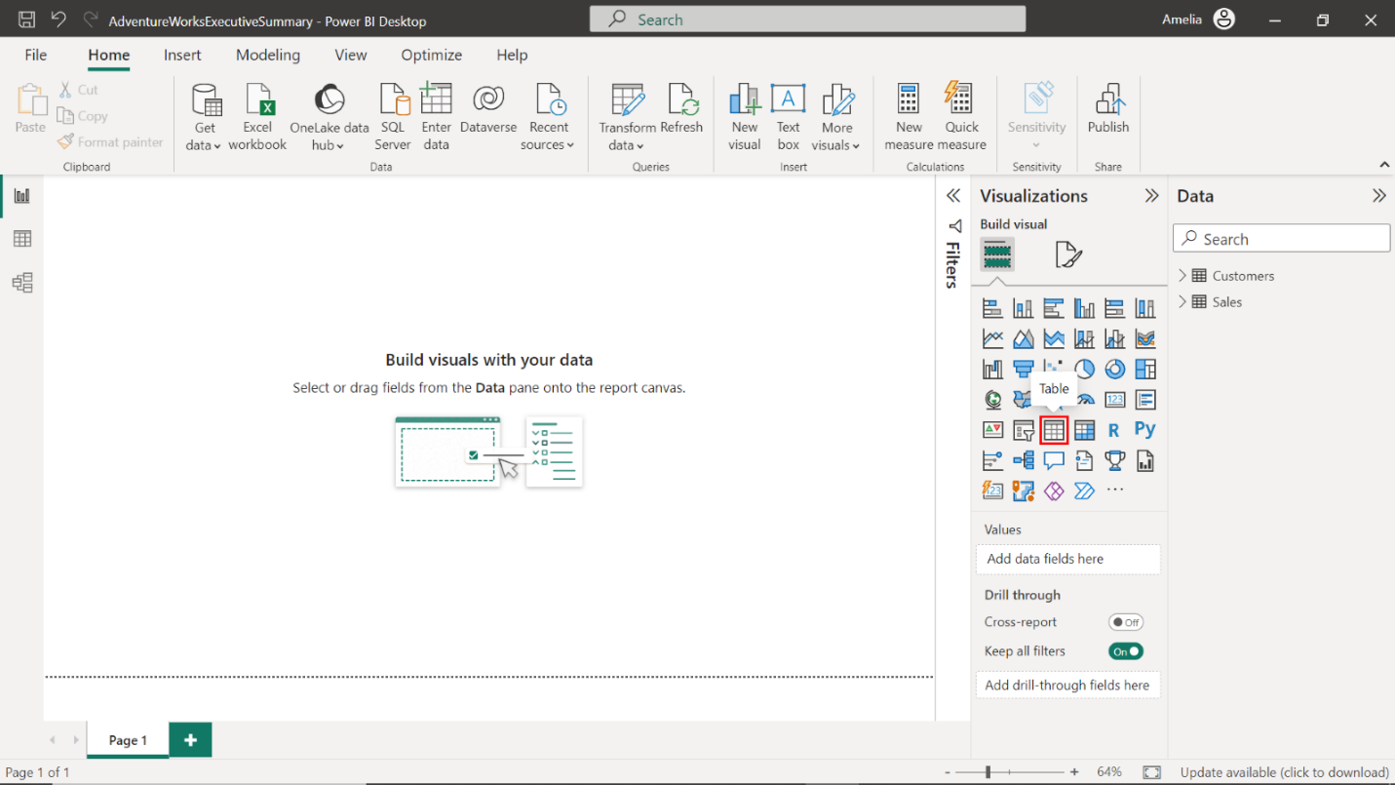

1. Find the **Data** pane on the right-hand side of the screen. Locate your **Sales** and **Customers** tables there. Select the **Sales** table to expand it and view its fields.

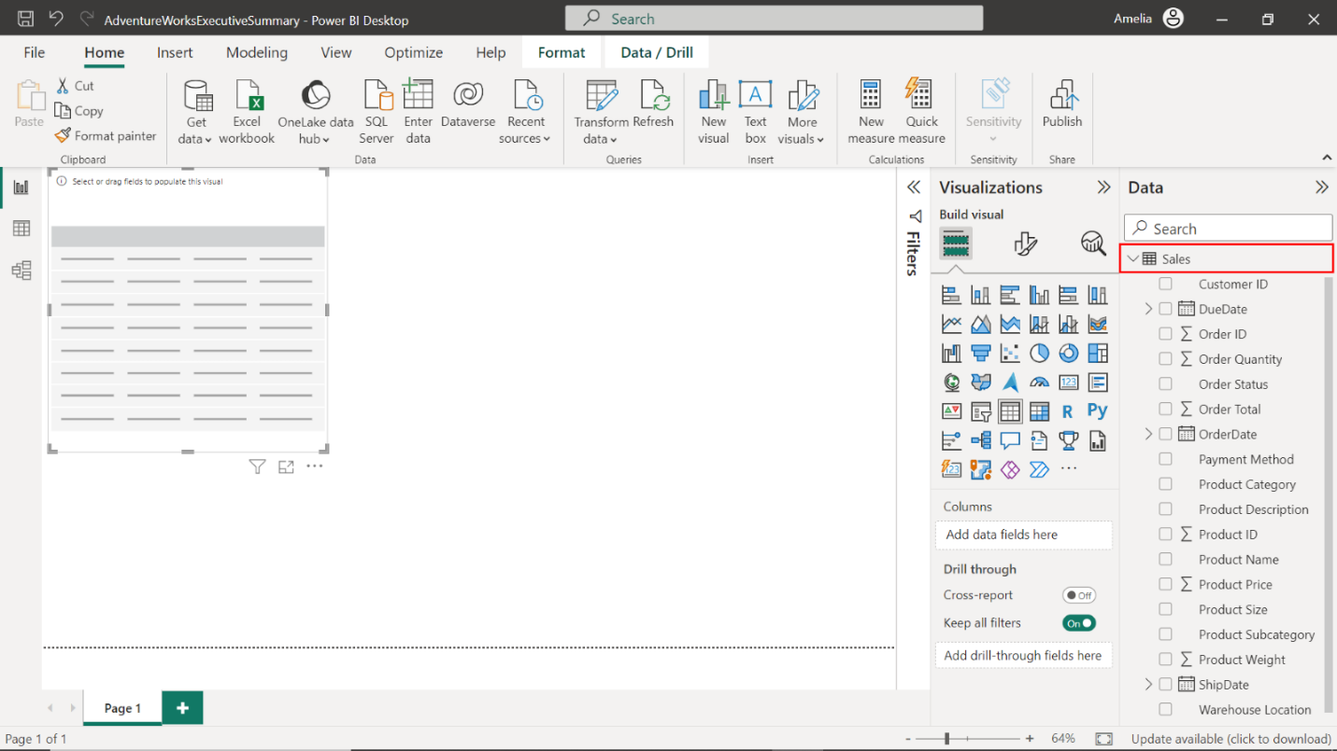

1. Drag **Product ID** from the **Data** pane to the **Columns** well in the **Visualizations** pane.

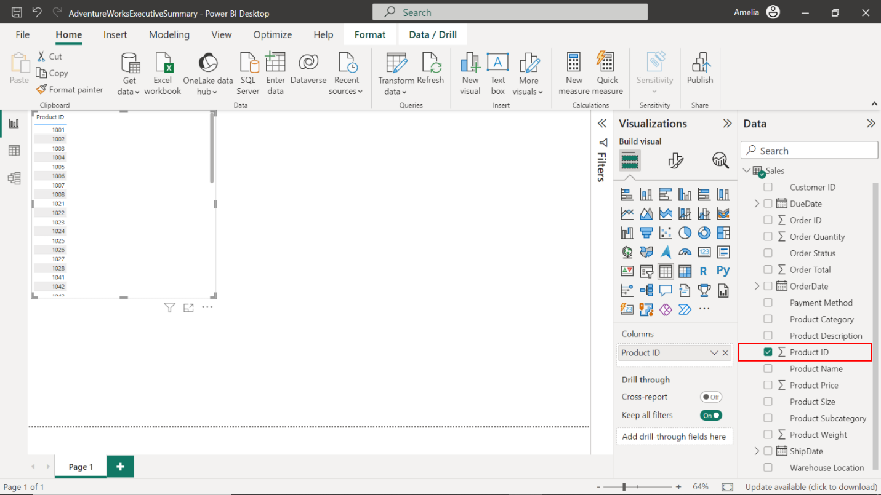

1. Next, drag **Product Name**, **Order ID**, **Order Status**, and **Order Total** into the same **Columns** well.

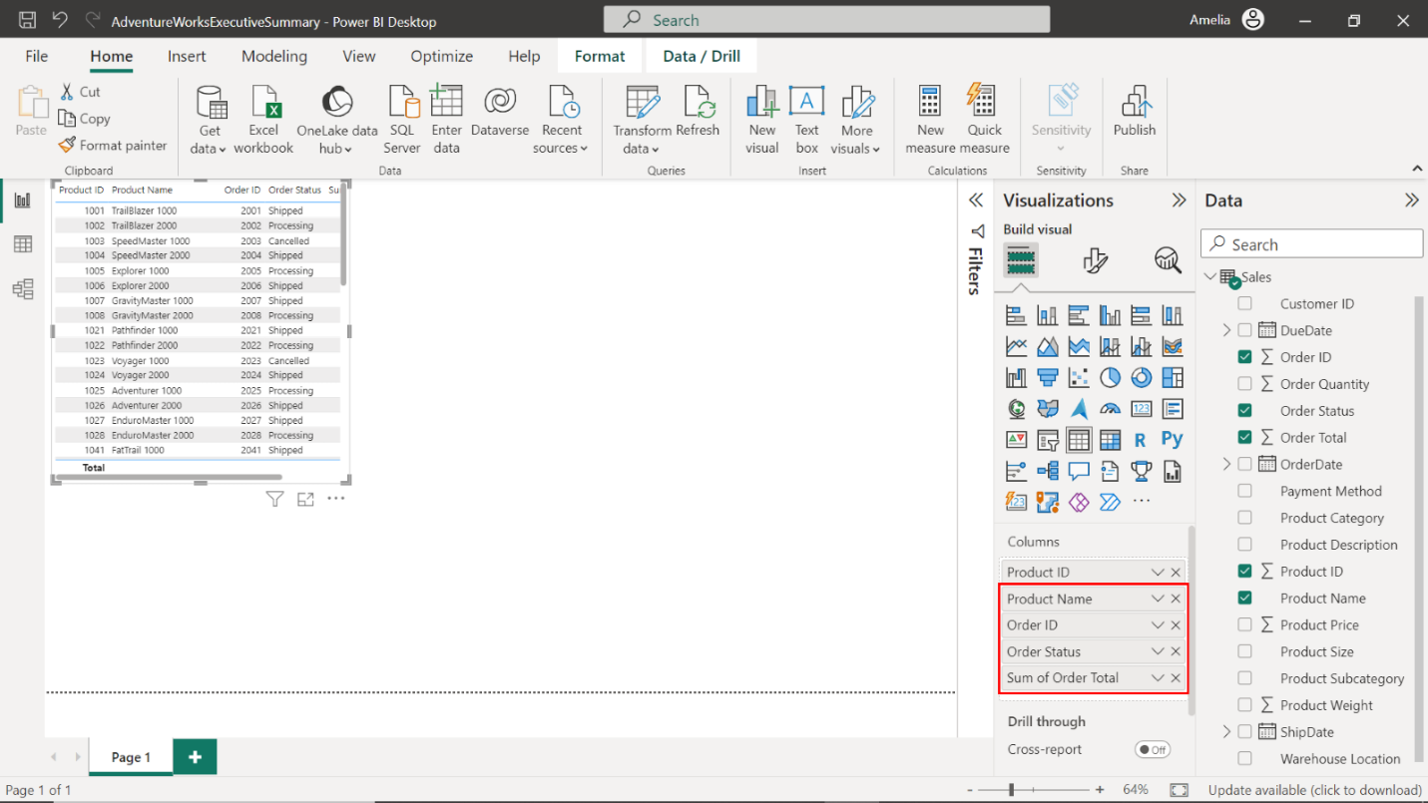

1. To format this table visual and change its appearance, select the **Format** tab. Expand the **Style** presets option and select the **Minimal** preset from the available dropdown.

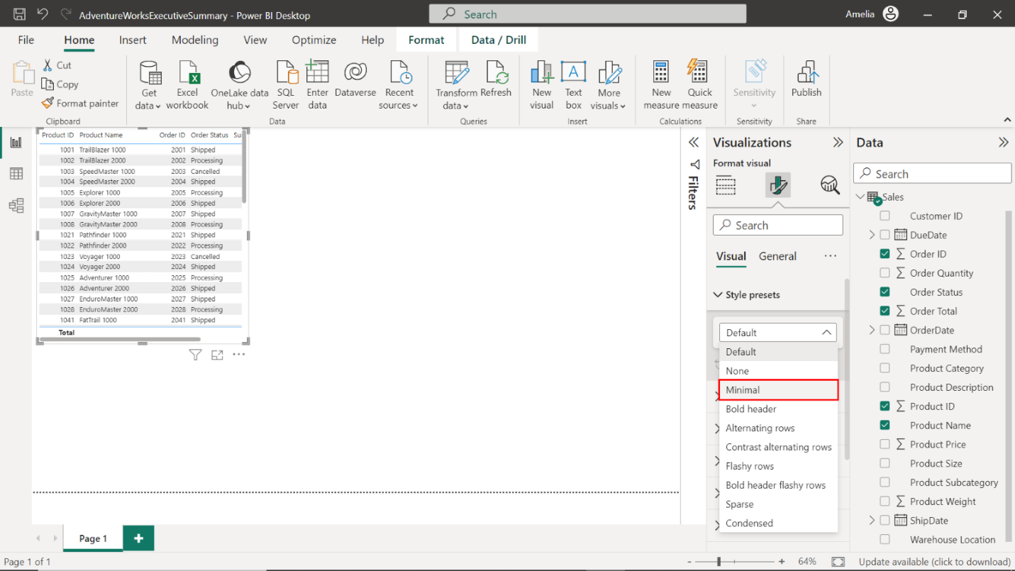

1. You will notice that your table is a bit small or not well-positioned. Select the edges of the table visualization box on your canvas to resize it and place the visualization on the right side of the canvas.

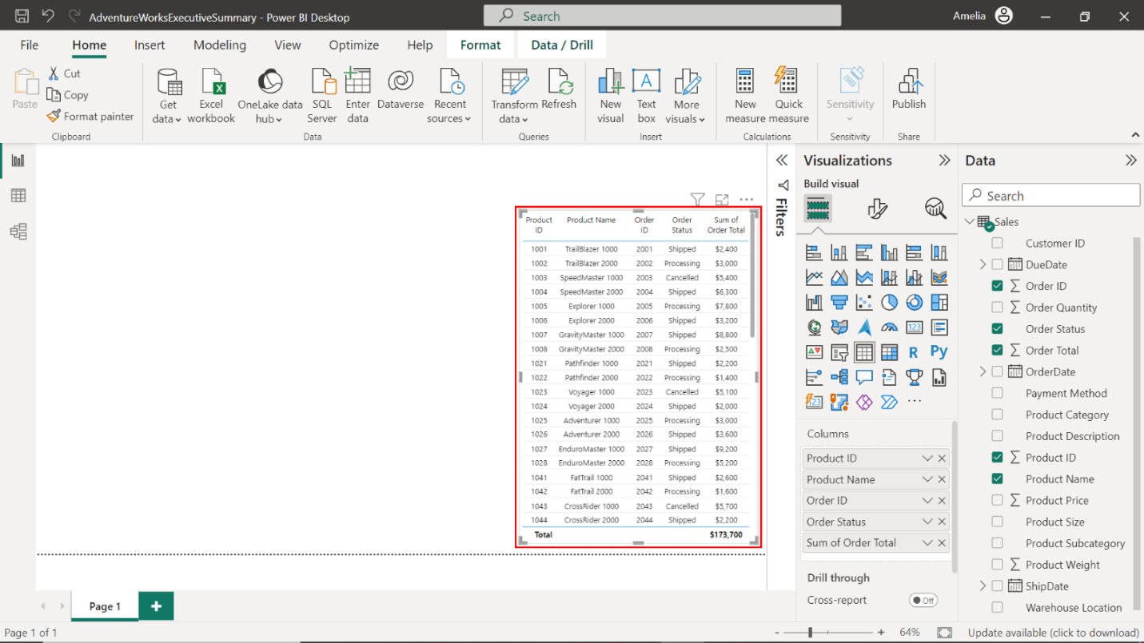

**Column chart**

*It’s not enough to know what sold; it’s crucial to know what’s selling dominantly and what’s not leaving the warehouse. A column chart instantly shows which product categories at Adventure Works are revenue generators and which need a strategic revisit.*

1. Select the white space of your canvas to deselect the table visualization. Then, select the **Clustered Column** chart icon in the **Visualizations** pane. An empty column chart will appear on the canvas.

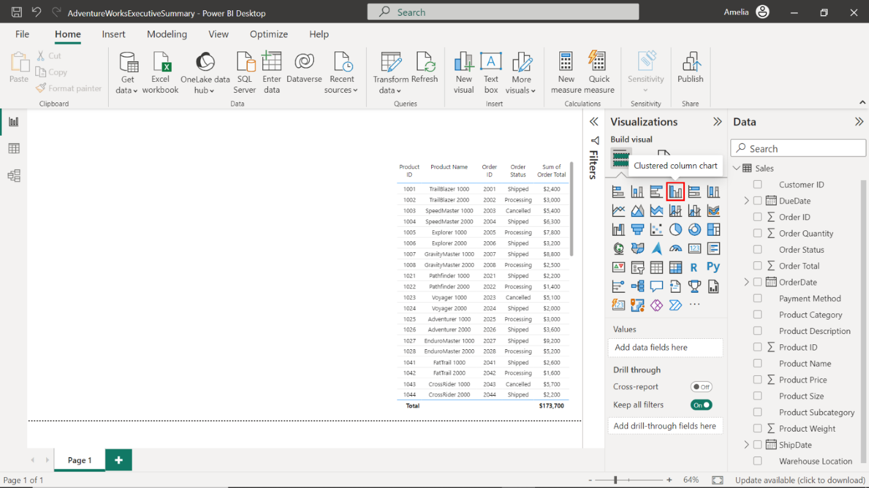

1. Drag **Product Category** from the **Sales** table and drop it into the **X-Axis** well.

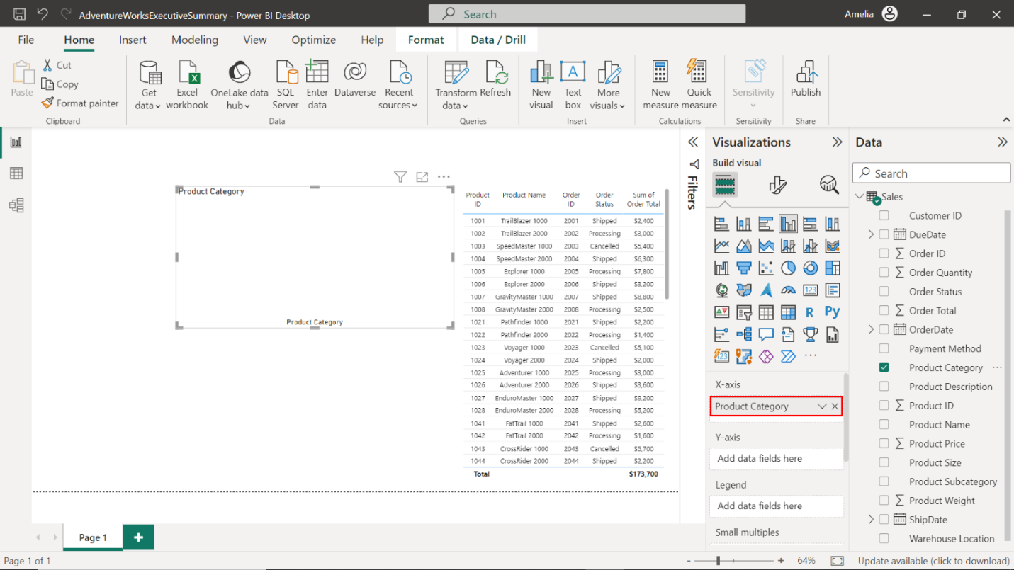

1. Now, drag **Order Total** from the same **Sales** table and drop it into the **Y-Axis** well.

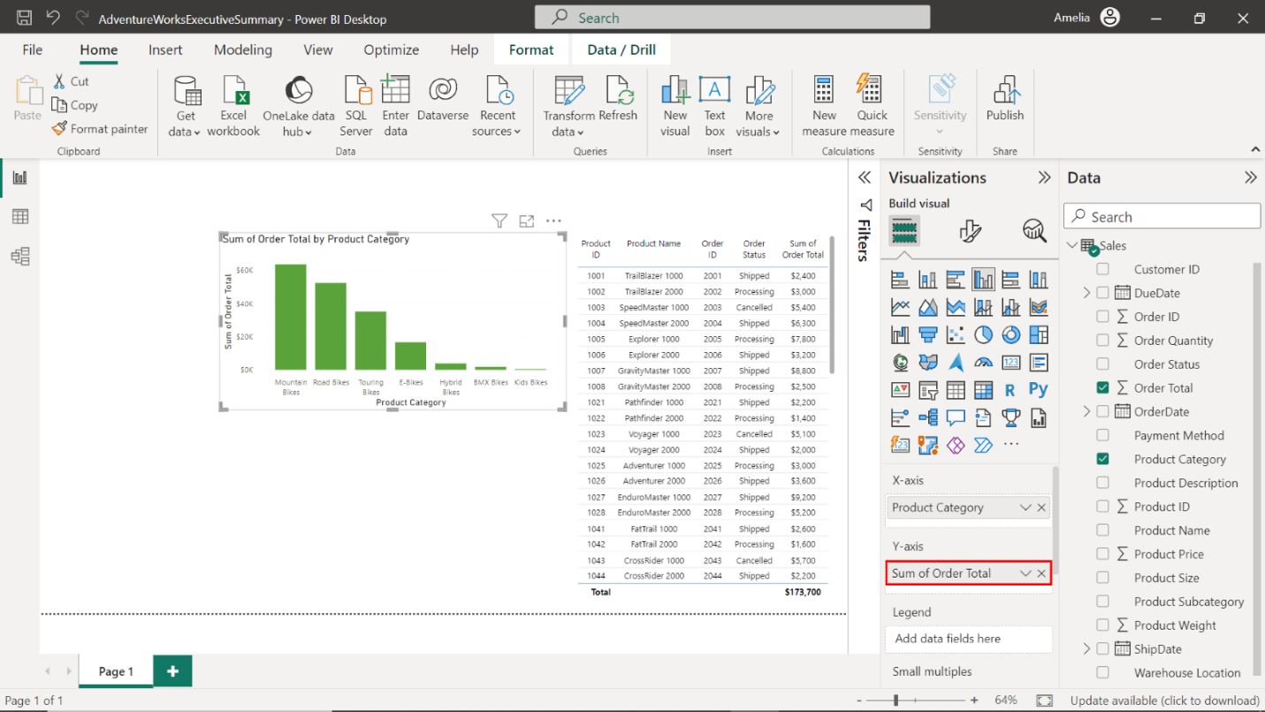

1. To format this column chart and change its appearance, select the **Format** tab. In the **Format** tab, locate the **Columns** > **Colors** option. Here, input **Dark Blue: #2D386D** for a unified look.

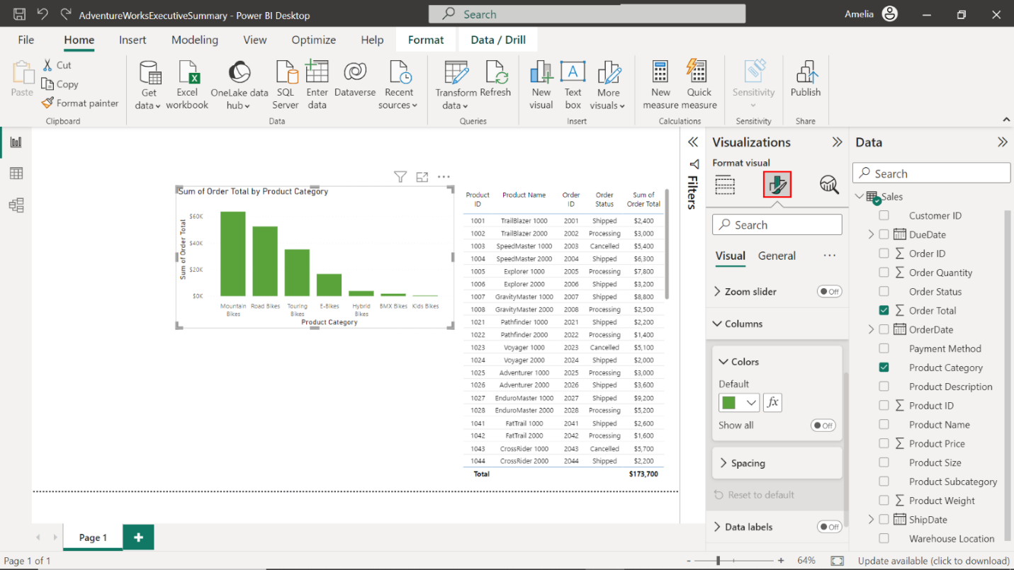

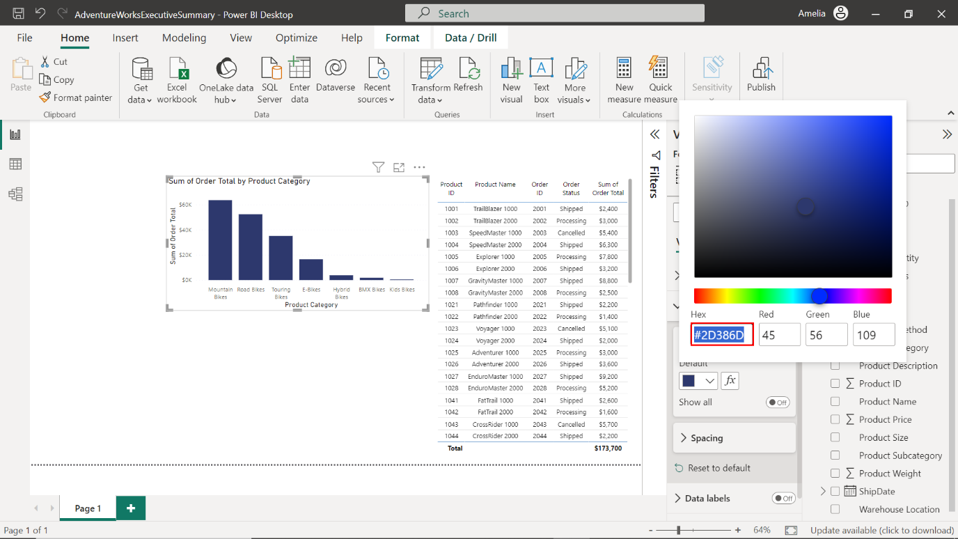

1. Drag **Order Quantity** and **Product Weight** fields from the **Sales** table into the **Tooltips** field well.

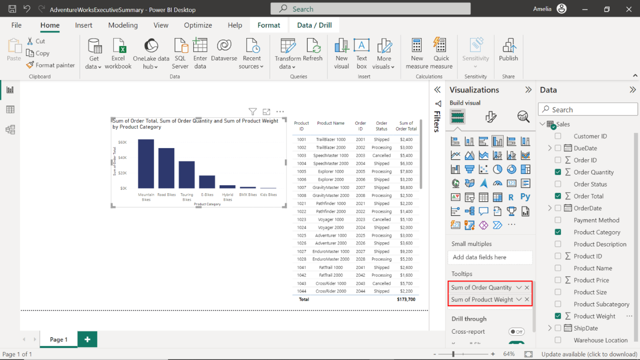

1. Upon selecting the ellipsis at the visualization's top right corner, select the **Sort axis** dropdown, followed by **Sum of Order Total**. Then select **Sort ascending** to sort the values in ascending order.

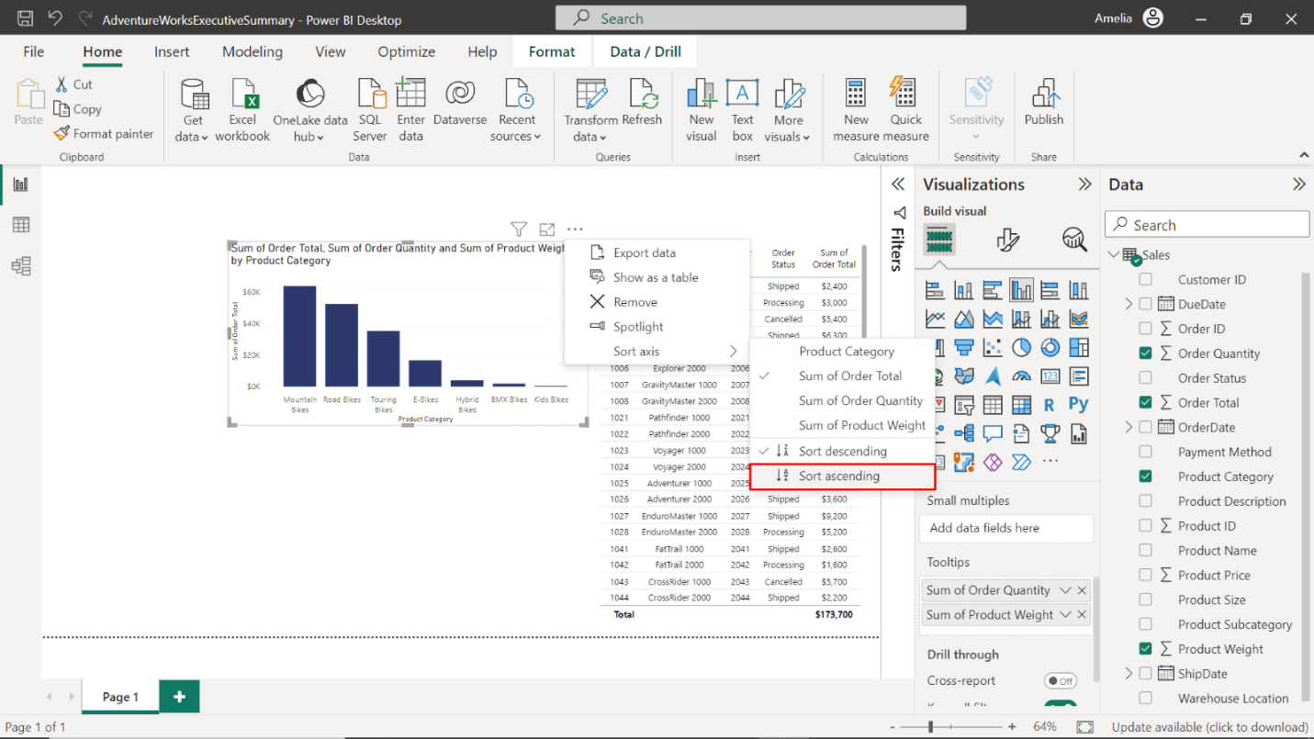

1. Observe the column chart results and note the **Product Category** with the lowest **Order Total** value. The **Order Total** for **Kids Bikes** is **$500**, making it the product category with the lowest overall sales.

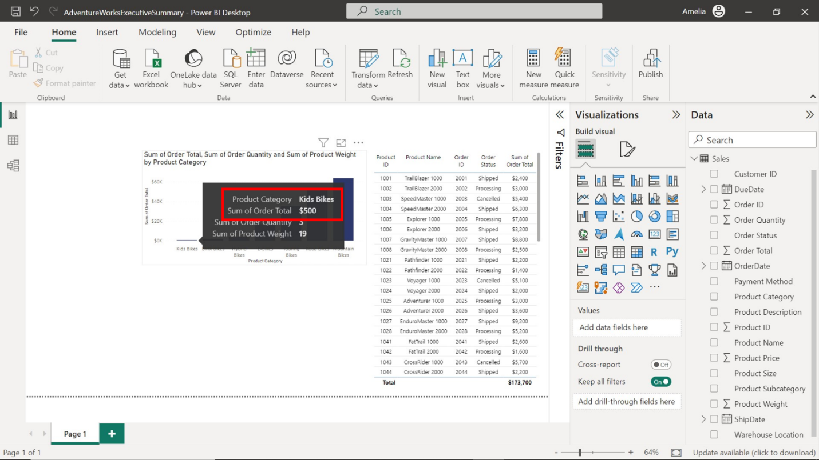

**Line chart**

*Remembering the conversation while seated in the executive suite, you overheard the Adventure Works executive team ponder “When did the sales peak? When did they drop?” as their seasonal strategies depend on these insights. Sales figures are meaningless without context, so you decide to take action and create a line chart.*

1. Select the canvas's empty space to deselect the column chart. Now, select the **Line chart** icon in the **Visualizations** pane. An empty line chart will appear on the canvas.

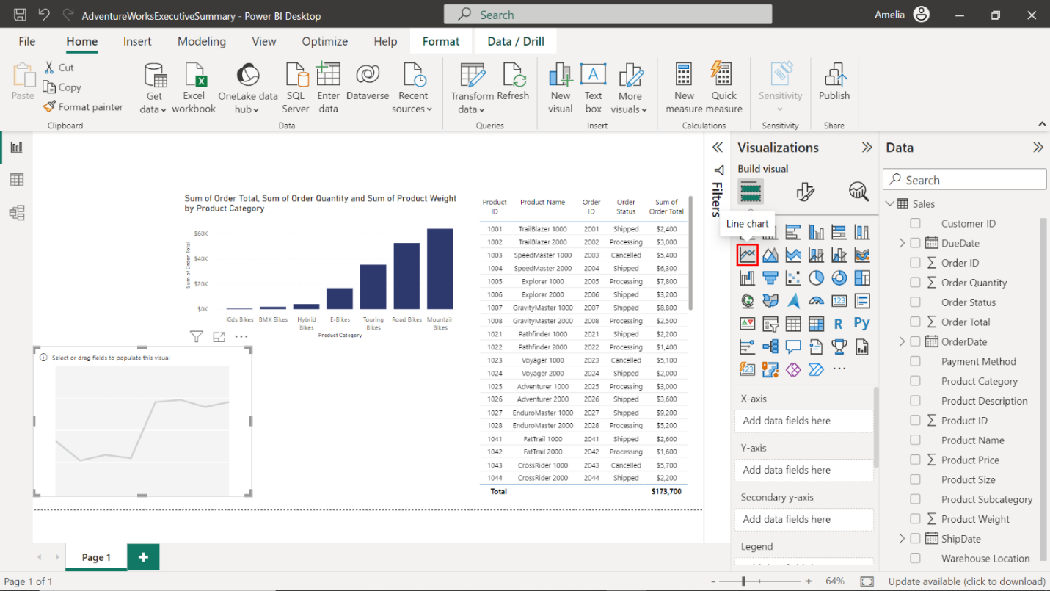

1. Drag **OrderDate** from the **Sales** table into the **X-Axis** well.

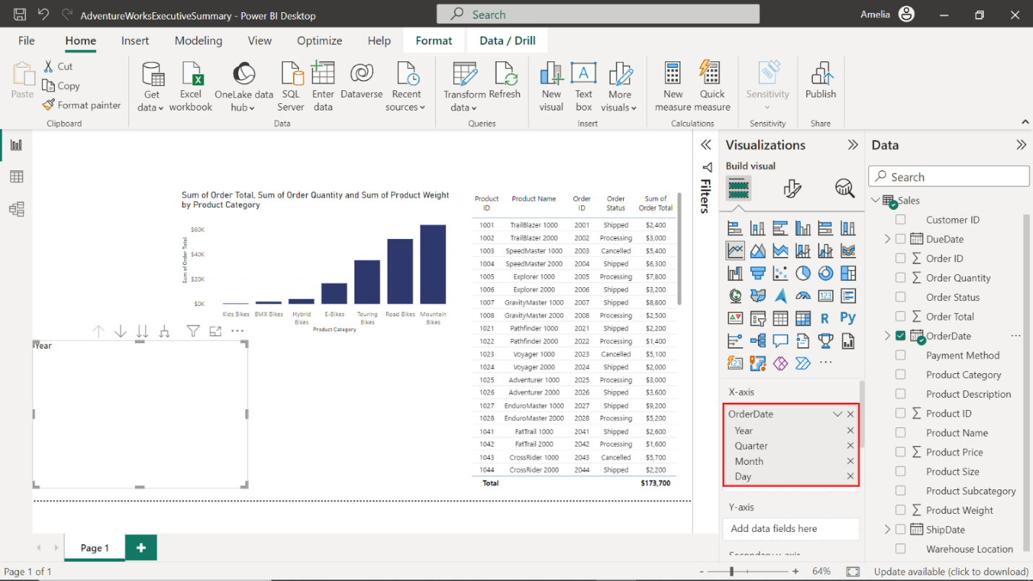

1. Then, drag **Order Total** and put it in the **Y-Axis** well.

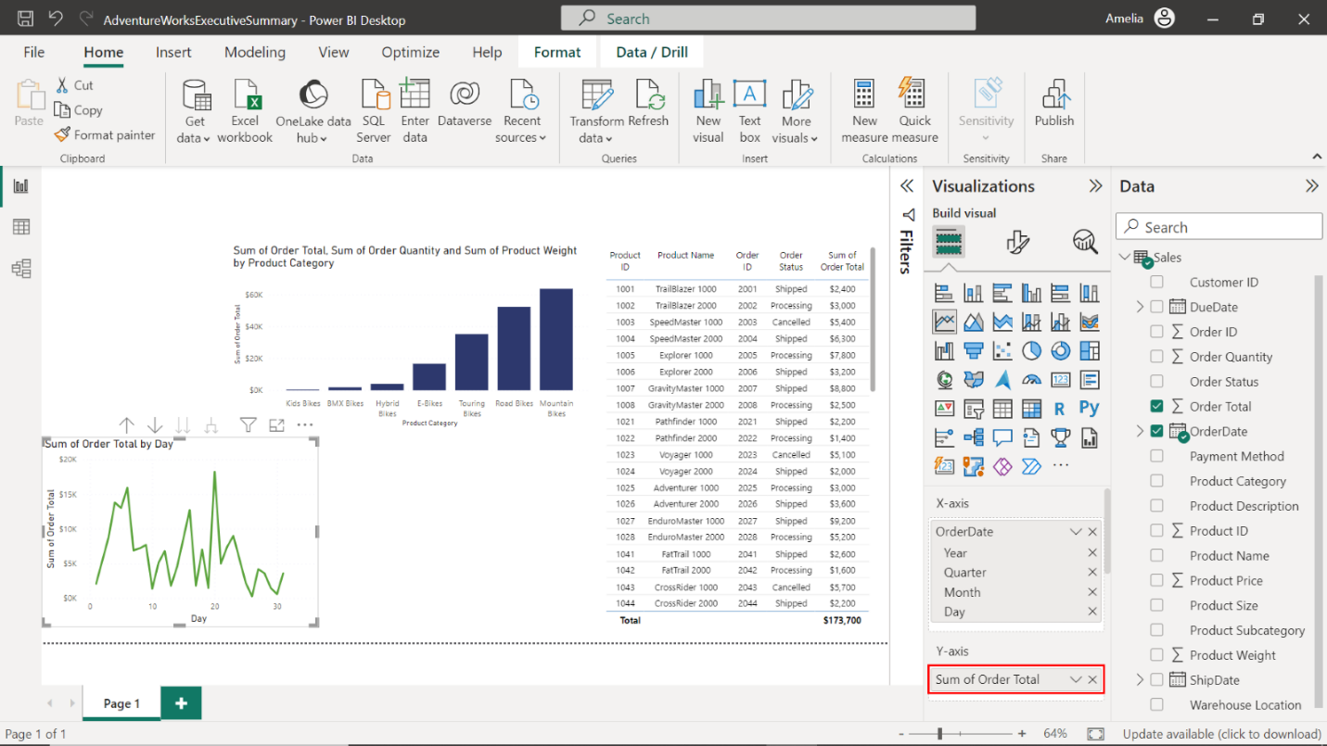

1. You will notice the **OrderDate** appearing too cramped. To fix this, select the edges of the **Line chart visualization** box on your canvas to resize it, and place it in the middle of the canvas, below the column chart, next to the table visualization.

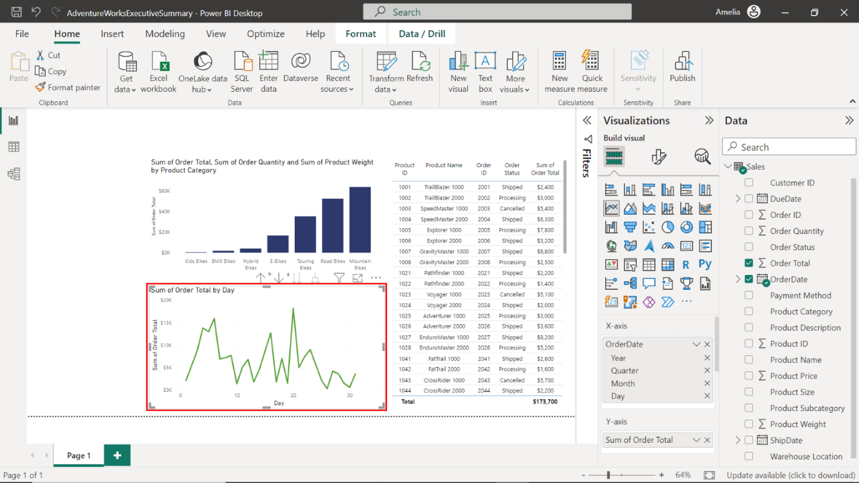

**Step 2: Create KPIs**

*KPIs offer the executive team a precise performance check into questions like “Are we hitting our sales goals? How expansive is our customer reach? How are we tracking our goals of being a global player?” These KPIs provide reality check and inspiration rolled into one.*

1. Ensuring that nothing is selected on the canvas, select the **KPI** icon in the **Visualizations** pane. An empty KPI chart will appear on the canvas.

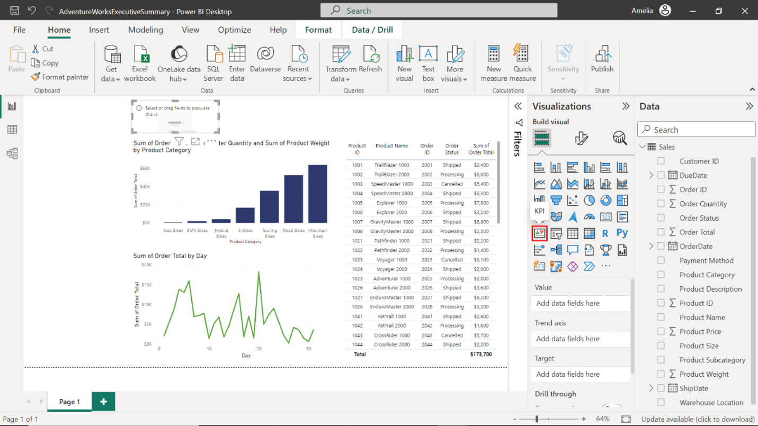

1. Drag **Order Total** from the **Sales** table to the **Value** field well.

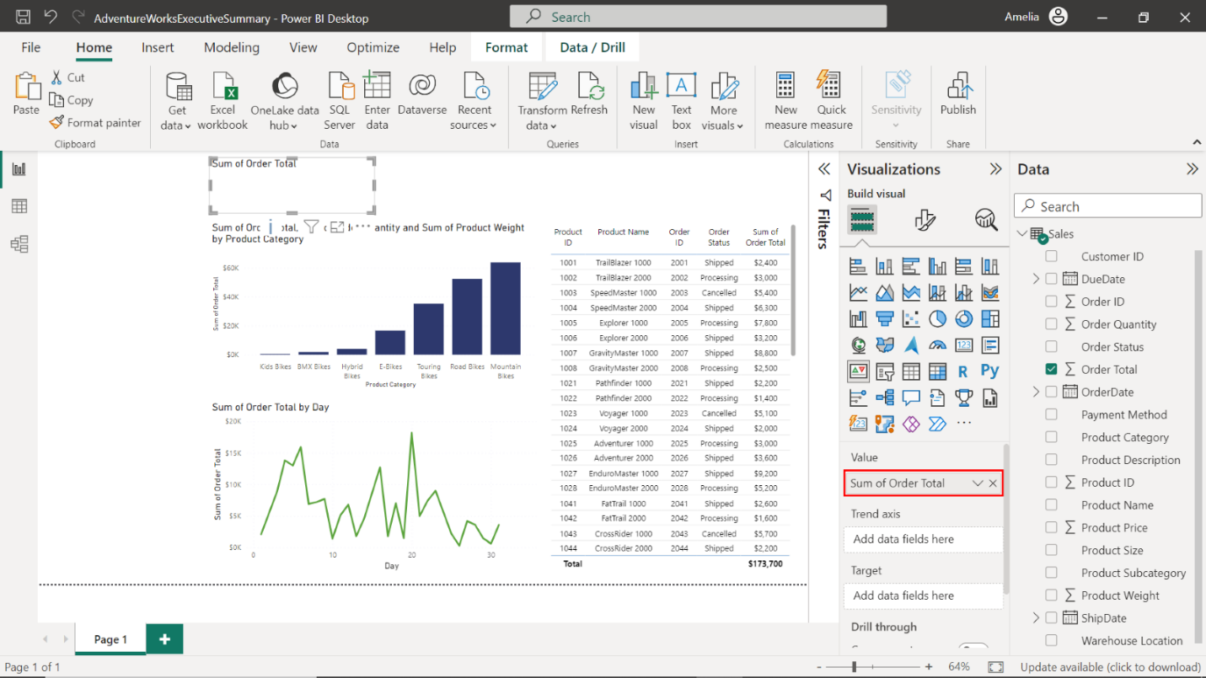

1. Then drag **OrderDate** from the **Sales** table to the **Trend Axis** field well.

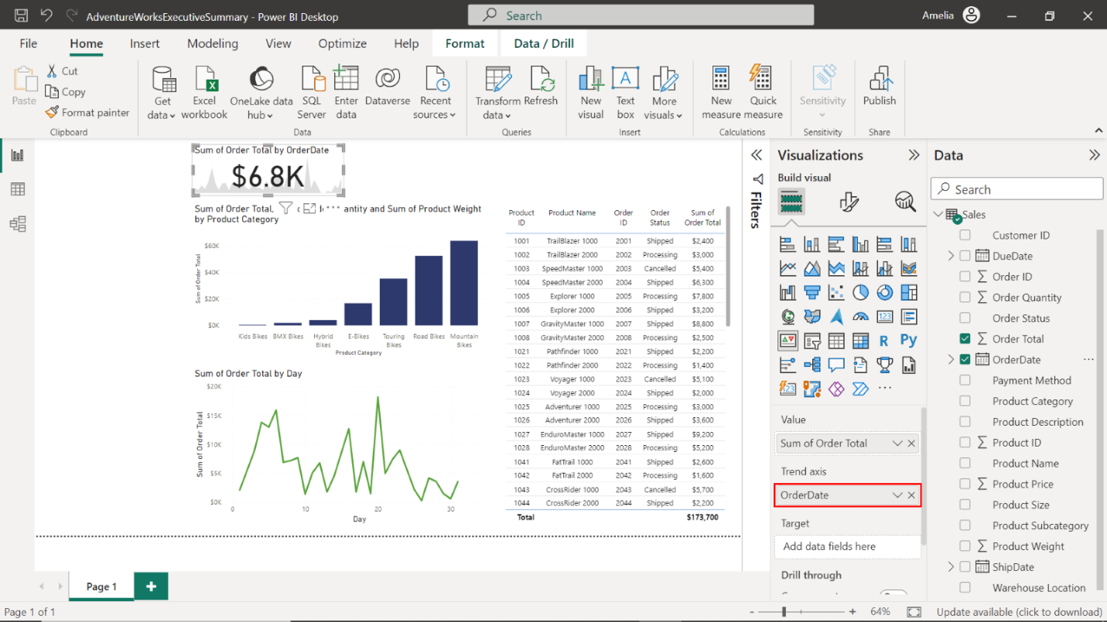

1. Repeat steps 1 – 3, adding two more KPIs:

* Drag **Customer ID** from the **Customers** table to the **Indicator** field well and the **OrderDate** from the **Sales** table to the **Trend Axis**. This will count the number of unique customers that have made a purchase with Adventure Works.

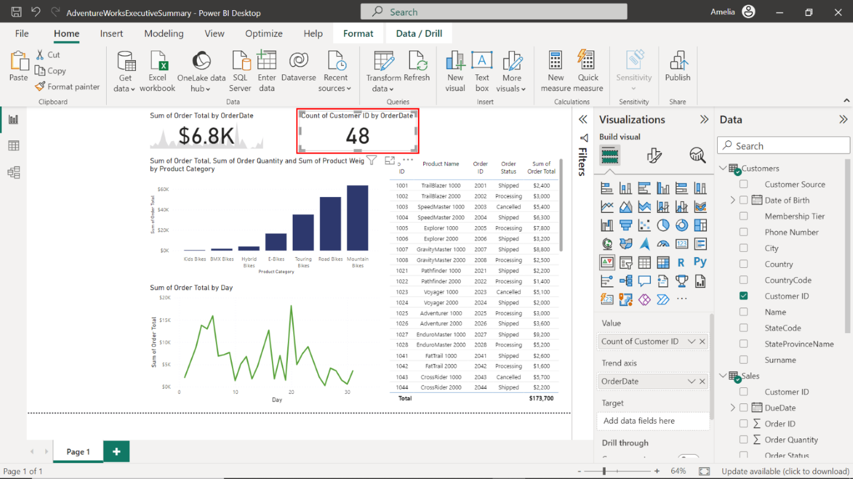

* Drag **City** from the **Customers** table to the **Indicator** field well and the **OrderDate** from the **Sales** table to the **Trend Axis**. This will count the number of unique countries that Adventure Works customers are located in.

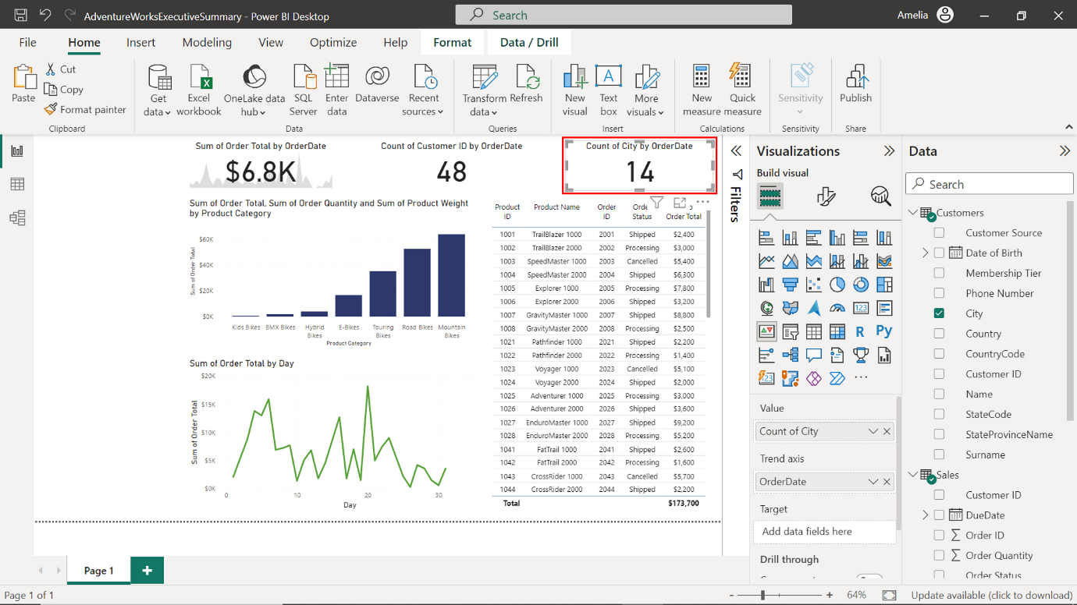

**Step 3: Setup forecasting**

*You know that forecasting is a critical feature in Power BI that enables the prediction of future trends based on historical data. This is especially useful for executives at Adventure Works who are looking to make data-driven decisions for the future.*

1. The first step is to select the line chart visualization you've created. This will bring up the related options in the **Visualizations** pane on the right-hand side of your Power BI workspace.

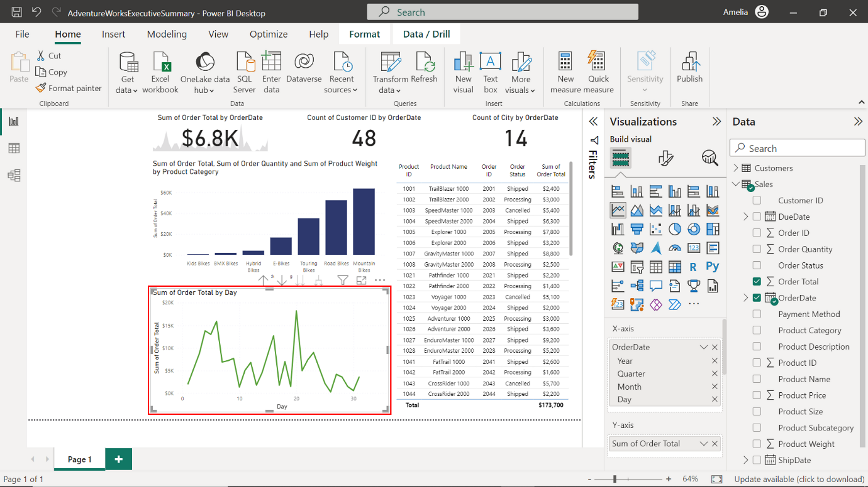

1. You'll notice different tabs in the **Visualizations** pane, namely **Fields**, **Format**, and **Analytics**. Select the **Analytics** tab, represented by a magnifying glass icon.

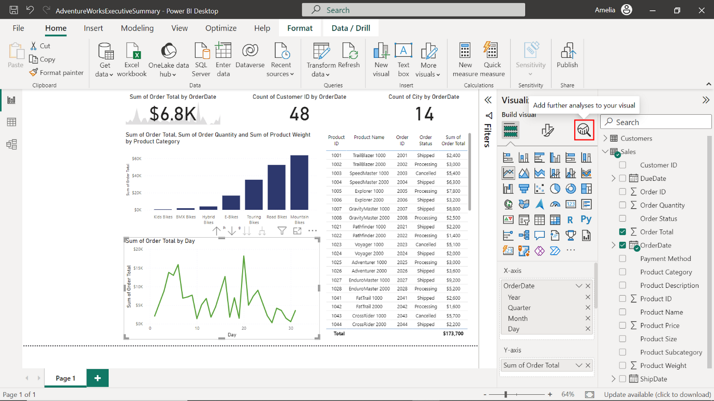

1. There are a variety of options for adding analytical information to your chart in the **Analytics** pane. Locate the **Forecast** option and toggle the switch beside it. This will add a forecast line to your chart.

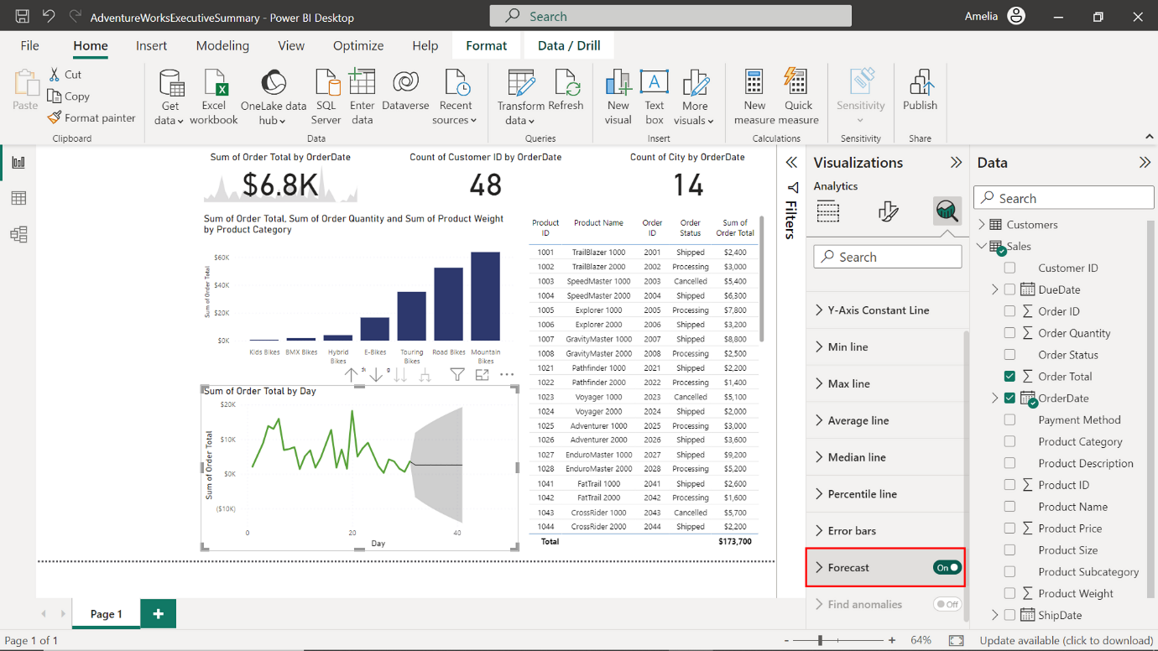

1. Once you've added the forecast, you need to adjust several parameters, such as **Seasonality** and **Confidence interval**.

* **Seasonality**: This is useful if your data has a repeating pattern. For the Adventure Works sales dataset, setting this to **12** is useful to account for monthly seasonality.

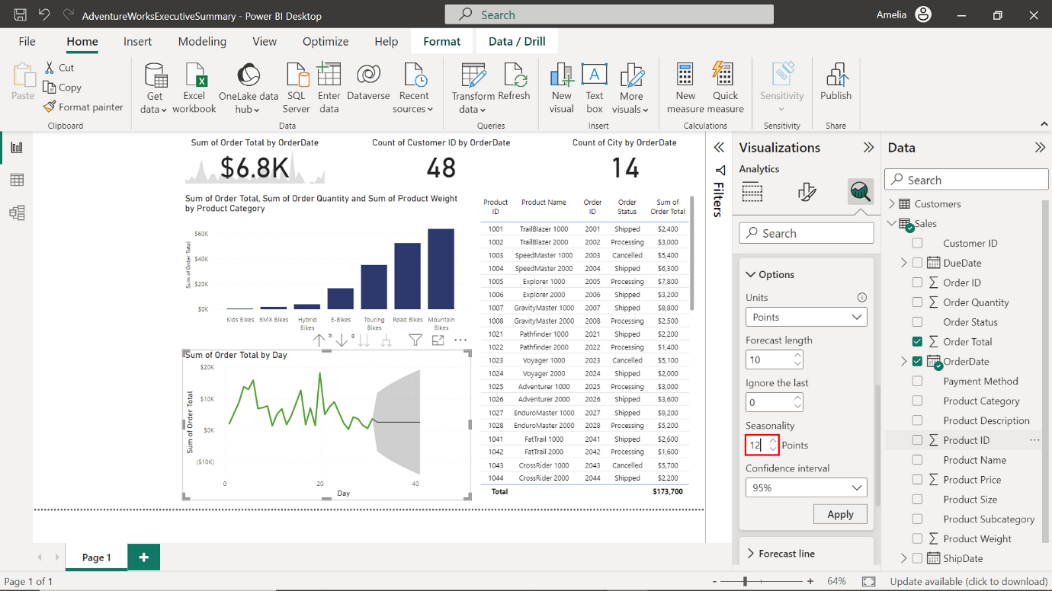

* **Confidence interval**: This is usually set at 95% by default, however you want to ensure the forecast is as confident as possible. Adjust the value to **99%**.

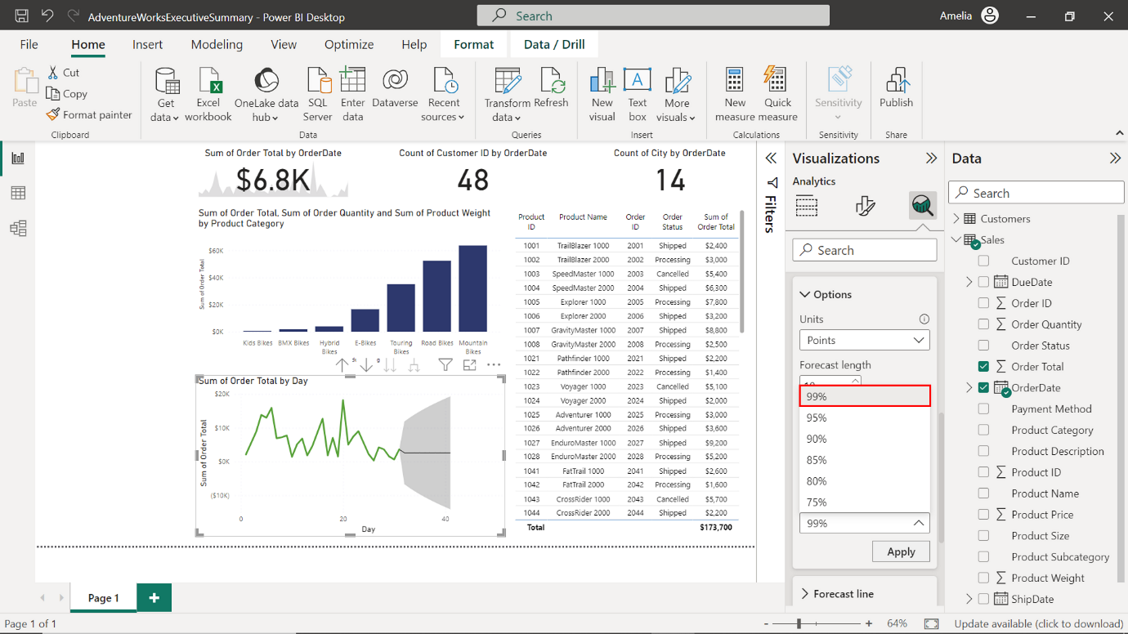

1. Once you've configured the parameters, select **Apply** to apply the changes. A forecasted line will appear on your line chart, in a different color with shading to indicate the confidence intervals.

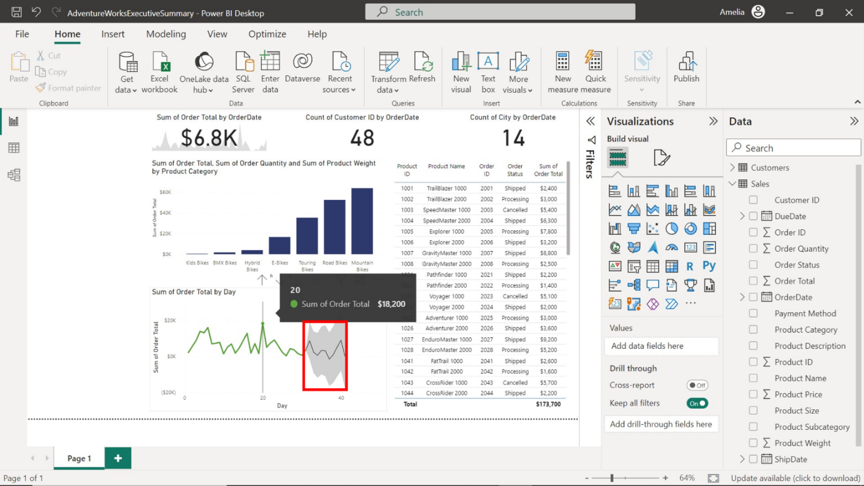

1. Observe the line chart and take note of day of the month with the lowest order total for Q1 in 2023. Your analysis shows that the **Order Total** for March 27th is $200, making it the day with the lowest sales.

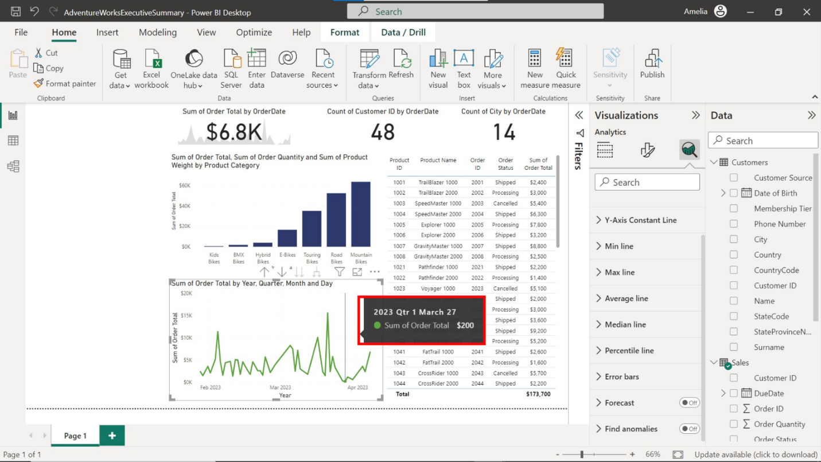

**Step 4: Configure Q&A**

*Instead of sifting through several visualizations, you want Adventure Works stakeholders to have a conversation with your data. For the executive team, the* ***Q&A*** *feature could be transformative, allowing them to interact with the data in a conversational manner and generate insights on-the-fly.*

1. On the right-hand side of the Power BI Desktop in the **Visualizations** pane, locate and select the **Q&A** icon that looks like a chat bubble.

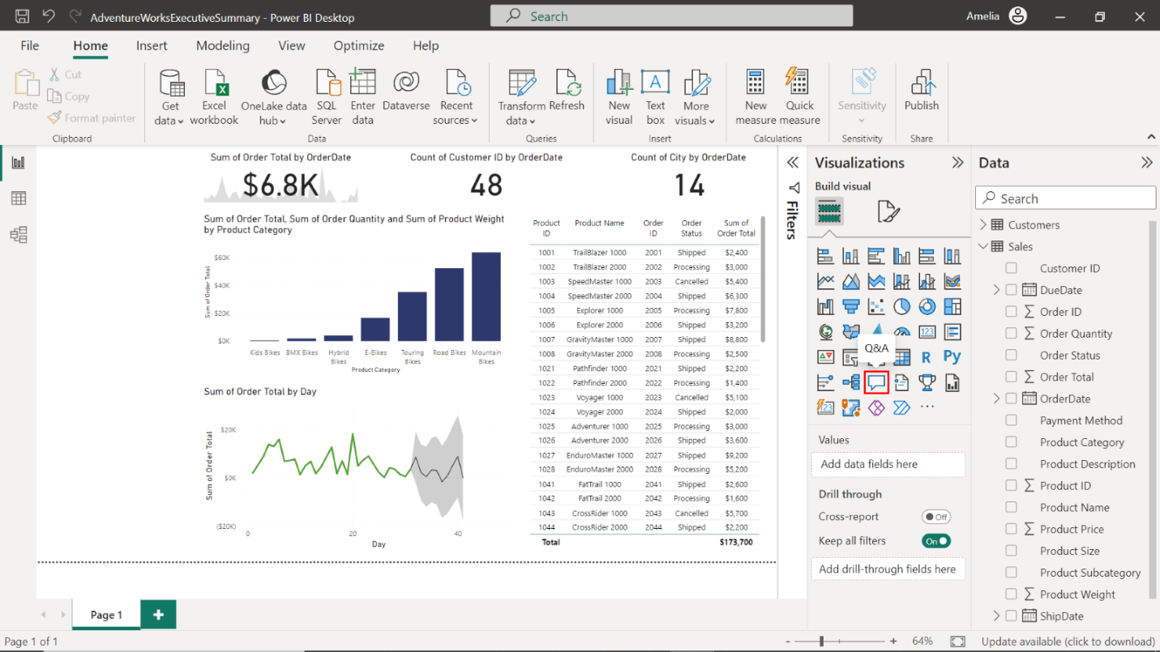

1. Upon selecting the Q&A icon, a Q&A visual will appear on the canvas. The initial size of the Q&A box may not fit your needs. Select and drag the corners to resize the box and select and drag the title bar to reposition it on the left side of your canvas.

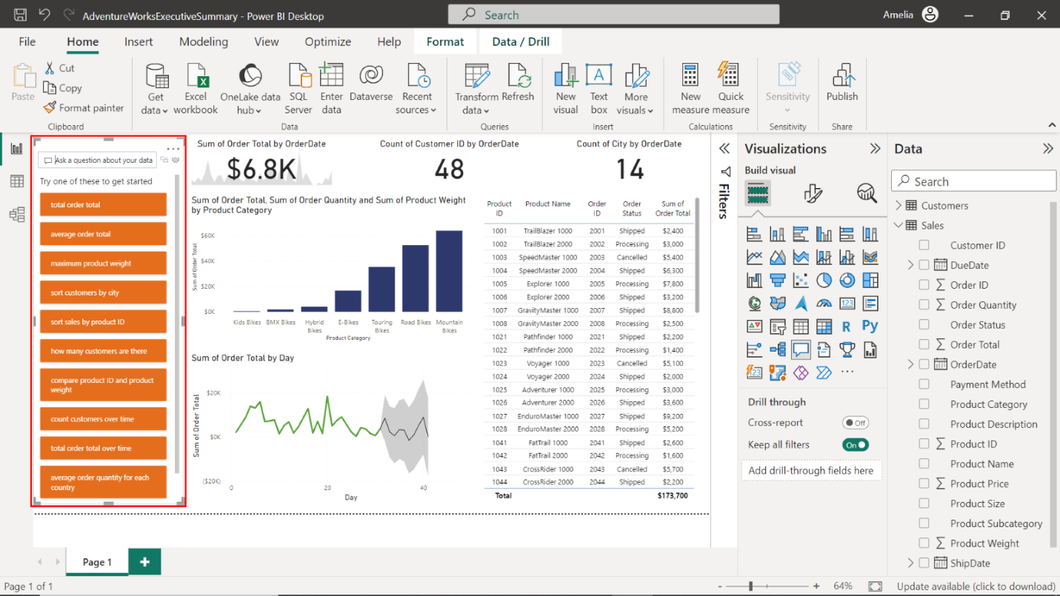

1. Inside the Q&A box is a text prompt titled **Ask a question about your data**. Select inside this box, type the following queries, and note down the results:

* Which customer **City** has the lowest average **Order Total**? Long Beach has the lowest average **Order Total** at $1,200.

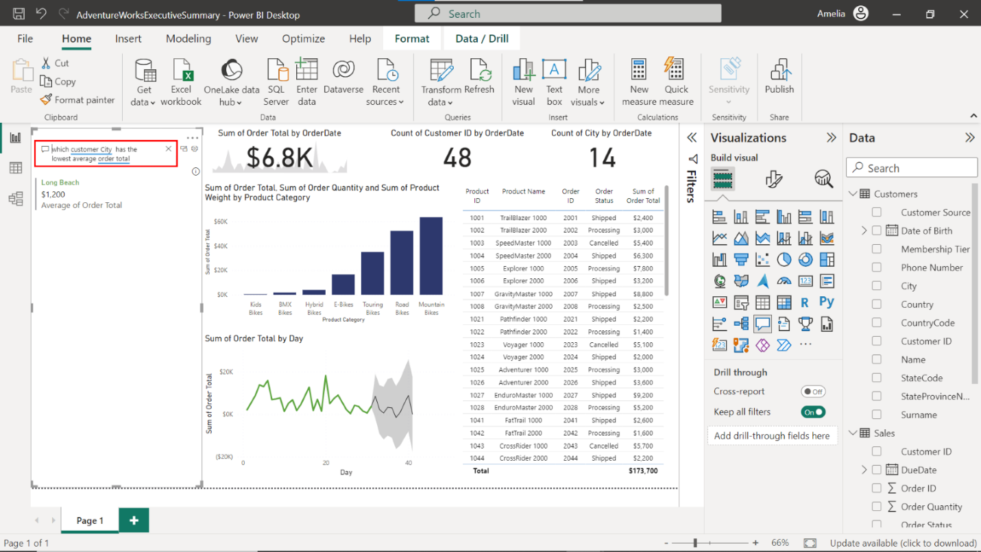

* Which **Product Category** has the highest average **Order Quantity**?**BMX Bikes** have the highest average **Order Quantity** at 2.00.

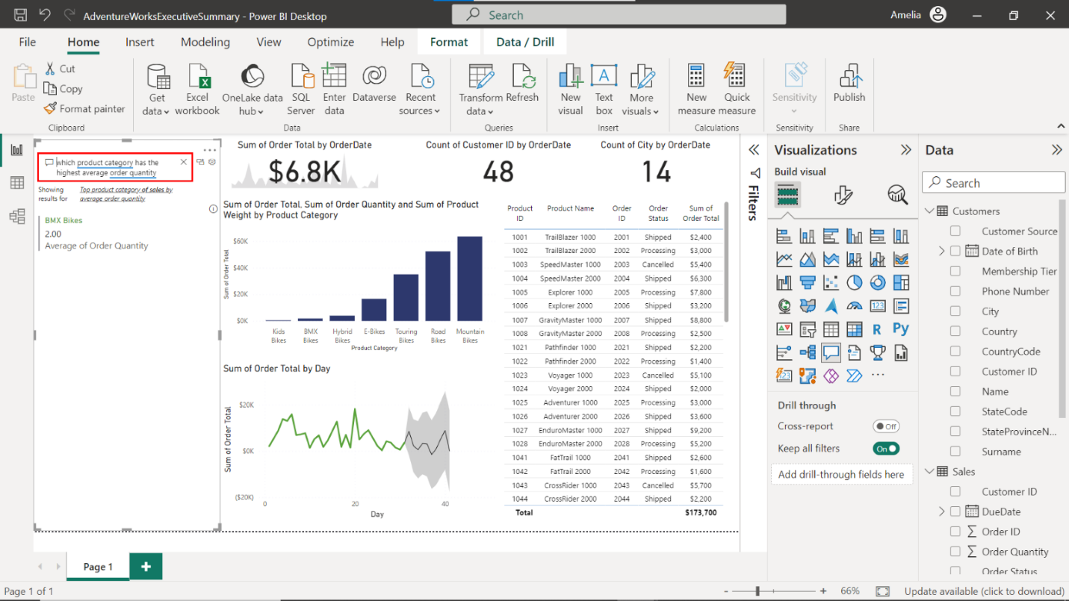

* Which **Product Subcategory** has the highest **Product Weight**? The **Downhill**subcategory has the highest **Product Weight**, registering at 151ounces.

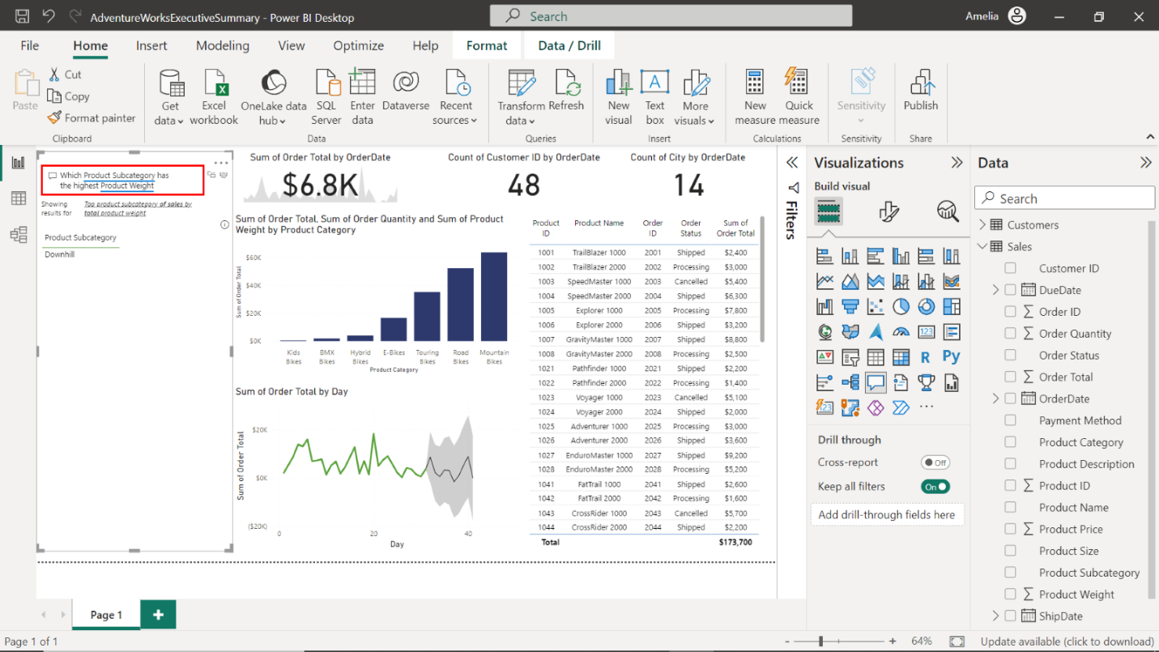

**Final output**

The following is an example report against which you can compare your solution:

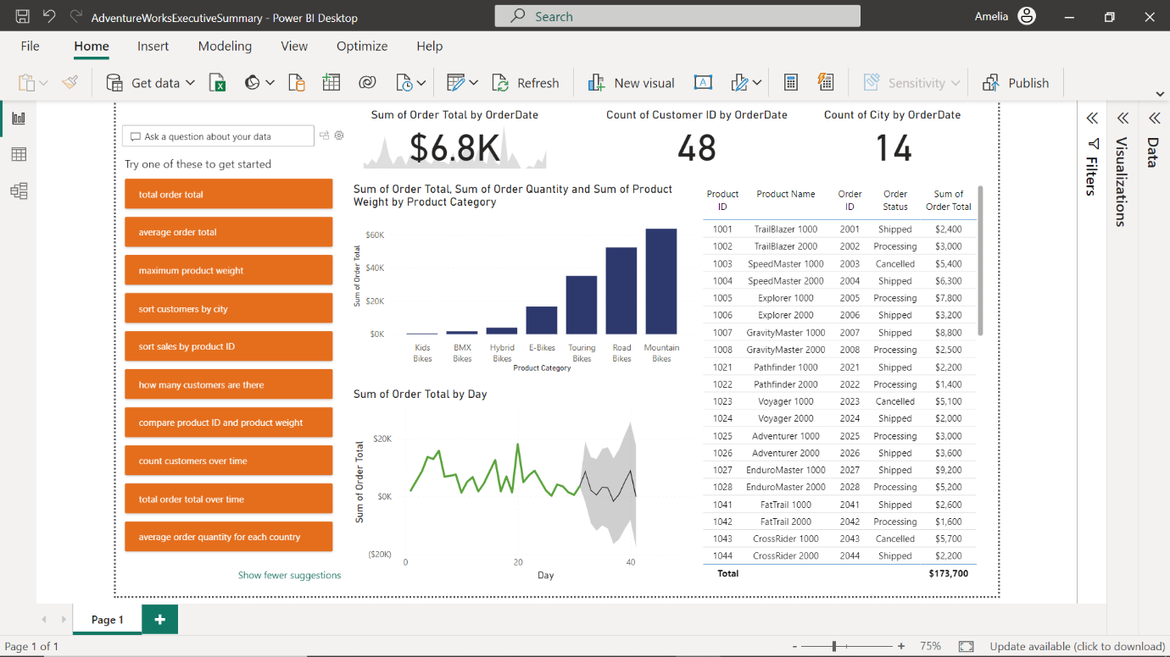

**Conclusion**

As you wrap up this transformative journey, it's essential to pause and consider the impact of what you've just achieved. You've not only mastered the tools to create compelling Power BI reports, but you've also unlocked the hidden stories within Adventure Works' vast data. In doing so, you've empowered decision-makers to act swiftly, strategically, and substantively. Remember, every visualization and every KPI you set could be the butterfly effect that drives a revolution. Now, go out there and turn those numbers into narratives that can drive business outcomes!